UNIT.4: ATOMIC STRUCTURE
Contents:
- Introduction
- Dalton´s theory
- The atom is not indivisible.
- Thomson´s model.
- Rutherford´s experiment; Rutherford´s model for the atom.
- Representation of atoms: atomic number, mass number; ions.

- Introduction
There is a smallest unit of substance mantaining its properties. This smallest unit may be only a single atom or a group of atoms chemically joined together. In this unit we´ll see about the atom, the fundamental blocks of the universe, the three basic subatomic particles (protons, neutrons and electrons) and how they are located, mainly electrons, because chemical reactions depend on the loss, gain or sharing of them, and the relationship between electrons arrangement and the position of the elements in the periodic table.
People has been asking themselves about how the matter is composed since the time of the ancient Greeks. Aproximatetly in the beginning of the fifth century before Christ (B.C.), a group of Greek philosophers called presocratics proposed the first theory about the composition of matter. They thought about the matter to be continuous. Later in the next century, Leucippus and Democritus thought about the matter to be formed of atoms (but not in the sense we used to talk about atoms).
A-THOMO means A (without) Thomo (part, think of the volumes of an encyclopedia), without parts. The ancient Greeks thought of atoms to be like a marvel or a billiard ball…much more tiny.
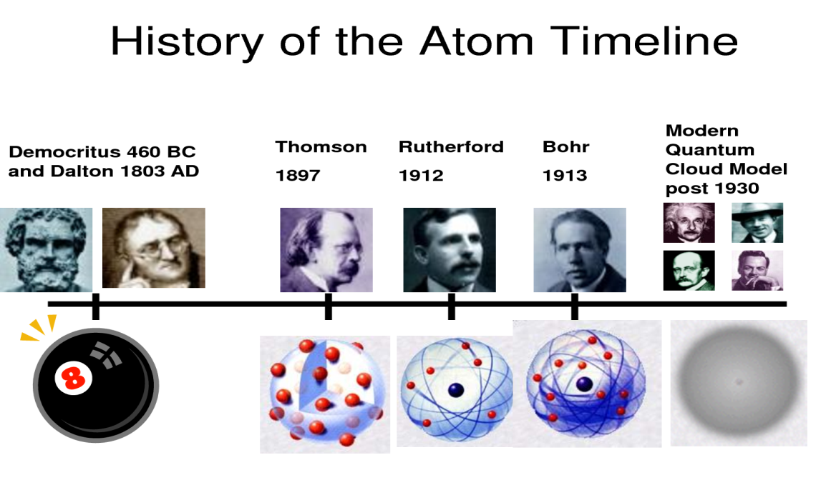

- ATOMIC DALTON´S THEORY
The atom is the smallest part of matter that represents a particular element. For quite a while, the atom was thought to be the smallest part of matter that could exist. It was not until the latter part of the 19th century and early part of the 20th, scientist discovered that atoms are composed of certain subatomic particles and that, no matter what the element, the same subatomic particles make up the atom.
During XVIIIth century, developed the first experimental laws about chemical reactions, as the Lavoisiers´ Conservation of mass law. To explain these laws John Dalton in the early XIXth, developed the first modern atomic theory of matter (remembering the ideas of Democritus and Leucippus).
Here we have the Dalton´s theory hypothesis about matter:
- Matter is make up by tiny, separated particles, unchangeable and with a fixed size called atoms (atom means not separable).
- The atoms that make up an element are all the same, and are different from those of another element.
- Chemical compounds are formed by the union of different elements in a fixed, simple ratio.
- In a chemical reaction, atoms not create nor destroy but rejoin in a different way.
The atom is the smallest part of an element that takes part in a chemical reaction.
Dalton believed that atoms do not have an internal structure, they could be thought as little marbles. Today we know the atoms have an internal structure and are formed by some internal or subatomic particles. But the way to know how the atom is in reality, was very, very large…
- The atom is not indivisible
In this section we are going to study different phenomena that give for sure that atom is not like Dalton said, as a billiard ball, but has some particles in it. These particles are the subatomic particles and as you know they are: protons, electrons and neutrons.
The first of these phenomena is the static electricity and electric phenomena. Let´s see about it.
The electric phenomena were already Known for, yes of course, the ancient Greeks. They saw that rubbing a piece of amber with an animal´s fur, the amber attracted some light bodies. The amber was called elektron by the Greeks and so we know about the electron and electricity.
VIDEO 1: ELECTRICITY AND MATTER; http://youtu.be/5eD43uYcqzA
The conclusion of all this is that two kinds of electricity exist, and it is produced for a property of matter called charge. There are two kinds of charge, that are conventionally called as positive and negative. Charges of the same kind repel each other and of different kind attract. But where is this charge in matter?
VIDEO2:THE DISCOVERY OF THE ELECTRON: http://youtu.be/IdTxGJjA4Jw
Listen to this video and try to fill the blanks in the text bellow. Warning: The text bellow is not literally the text in the video.
J.J. Thomson was one of the greatest figures of Science. He became the director of……………………………………… in ………………………….. In …………….. he made an important discovery. He used basically a ……………………………………
In the first plate particles …………………………, then they are …………………………by the electrodes. Then they pass across ……………………..that are connected to a high voltage and follow their way until they hit the end of the…………………….. where a screen …………………….
In the modern version we can see more easily what Thomson did. He measured the bending of the beam crossing the plates so he can measure ……………………..of the particles.
Thomson found that the mass in this beam were …………………………..times lighter than the mass of a hydrogen atom.
Thomson discovered the first subatomic particle……………………….. We can use electrons as ways …………………………and look up …………………………….in…………………………………or in big machines like…………………..
Thomson discovered that the atom ………………………………………….but are smaller objects inside.
How did Thomson imagine the electrons in the atom? …………………………………………………………………………………………….This was called Thomson´s model. It was Rutherford´s experiment that made clear that Thomson´s model was wrong.
THOMSON DISCOVERED THE ELECTRON
THE ELECTRON IS THE TINIEST PARTICLE IN THE ATOM. IT HAS NEGATIVE CHARGE.

VIDEO 3: RADIOACTIVITY:
The radioactivity was accidentally discovered by the French physicist ……………………in 1896 who was working on the phenomenon of………………………., that consists in transforming the incident ultraviolet radiation into …………………………..
What did the box contain?.....................................................................................................
What did happen to the photographic plates?.......................................................................
Becquerel didn´t understand the reason of this behavior so he made some experiments with……………………….. and photographic plates. The influence of sunlight in the experiment was any.
He made experiments with different compounds of uranium in different chemical and physical conditions obtaining always the same radiation. He called this phenomenon ……………………… Some elements with atomic number greater than ……….. give out such radiations. The nucleus of these radioactive substances are unstable and can change ejecting …………………….. and …………………………………..
Radioactive substances can emit three kinds of radiations. In a magnetic field, radiations which deflect to the left are positively charged………………………, those which deflect to the right are negatively charged………………………………. and the ones which pass undeflected are neutral radiations called …………………………..
α-particles consist of ………………..and ………………….. so they are ionized atoms of …………………. α-particles have a smaller ………………………………………….as compared to ………………………….. and ……………………….
A β-particle is an …………………………… It originates in the nucleus and move very fast. They can cause radiation……………………
γ-rays are ……………………………………… and travel with the speed of light. γ-rays can easily pass through the ………………………. and destroy ……………. Hence, they are used in ……………………………. To kill ………………………..
http://youtu.be/TJgc28csgV0

A LITTLE SUMMARY: The subatomic particles.
So, now must be clear that there are many subatomic particles, but in order to be successful in chemistry, you really only need to be concerned with the three major subatomic particles, protons, electrons and neutrons.
The electron was discovered by J.J. Thomson as you already know. The proton was discovered by Ernest Rutherford in 1918. Finally the neutron was discovered by Chadwick in 1931. The table below summarizes the characteristics of these three subatomic particles.
The three major Subatomic particles
Name | Symbol | Charge | Mass (g) | Mass (amu) | Location
Proton | P⁺ | +1 | 1,673 10⁻²⁴ | 1 | Nucleus
Neutron | nº | 0 | 1,675 10⁻²⁴ | 1 | Nucleus
Electron | e⁻ | -1 | 9,11 10⁻²⁸ | 0,0005 | Outside nucleus

The atom contains these particles, but the atom itself has no charge. It´s neutral. How can an atom be neutral if it contains positively charged protons and negatively charged electrons? Obviously, the answer is that it has an equal number of protons and electrons, so the positive and negative charges cancel each other out. An atom can gain or lose electrons and acquire a charge. We call it a ion. A cation is a positively charged ion, that it is to say, an atom that has lose electrons. An anion is a negatively charged ion, an atom that has gained electrons.
Our following task is to determine the internal structure of an atom. We want to know how subatomic particles are distributed into the atom and how scientist arrived to this conclusion.
ATOMIC MODELS
The first model for the atom was defined by J.J. Thomson, who discovered as you know, the negative subatomic particle in the atom that is called electron. Thomson´s model is called Plum Pudding model.
Video 5: Plum Pudding model (3:50) . Take some notes about how Thomson imagined the electrons in the atom.
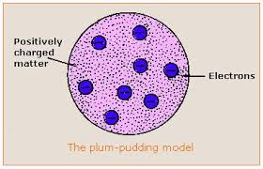

Video 6: Nucleus of an atom. The Rutherford´s experiment
The consequence of this experiment was that Rutherford discovered that atoms has a nucleus, a center, containing protons. Later, in 1931, Chadwick discovered the neutrons and scientist discovered that the nucleus also houses the neutrons.
So, the nucleus is very small and dense when compared to the rest of the atom. Typically, atoms have diameters that measure around 10⁻¹⁰ m. Nuclei are around 10⁻¹⁵ m in diameter. If a football field were an hydrogen atom, its nucleus would be about the size of a pea.
The protons are all crammed together inside the nucleus. Protons all carry a positive charge and like charge repel each other. So if all the protons in the nucleus repel each other why doesn´t the nucleus simply fly apart. There is a very intense force that counteract this repulsion and hold the nucleus together. Physicist call this force the nuclear glue. But sometimes this glue isn´t strong enough and the nucleus does break apart. This process is the radioactivity.
The so small nucleus contains nearly all the mass of the atom. For all practical purposes, the mass of the atom is the sum of the masses of the protons and neutrons. The sum of the number of protons plus the number of neutrons in an atom is called the mass number. The number of protons is the atomic number.
Chemists usually use the symbolization shown:
$${}_{Z}^{A}X$$
Where X is the atomic symbol of the element, A is the mass number (p⁺ + nº) and Z is the atomic number (p⁺). The number of electrons is the same as the atomic number always the atom remains neutral.

